Sponsorship Request Form
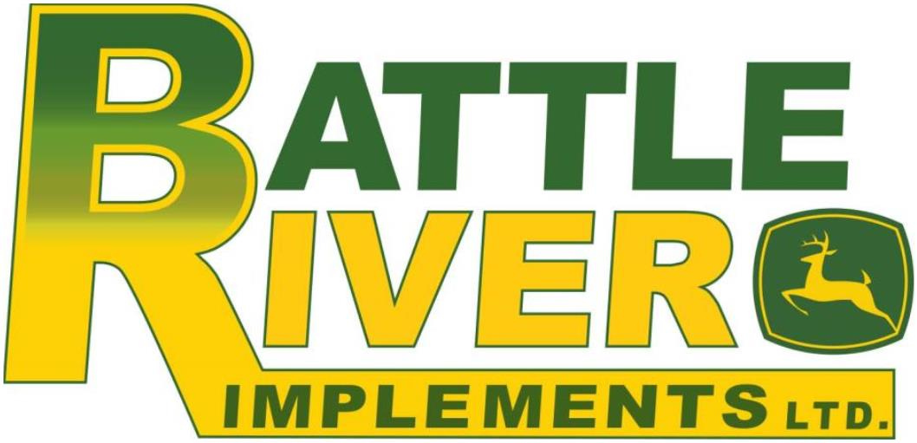
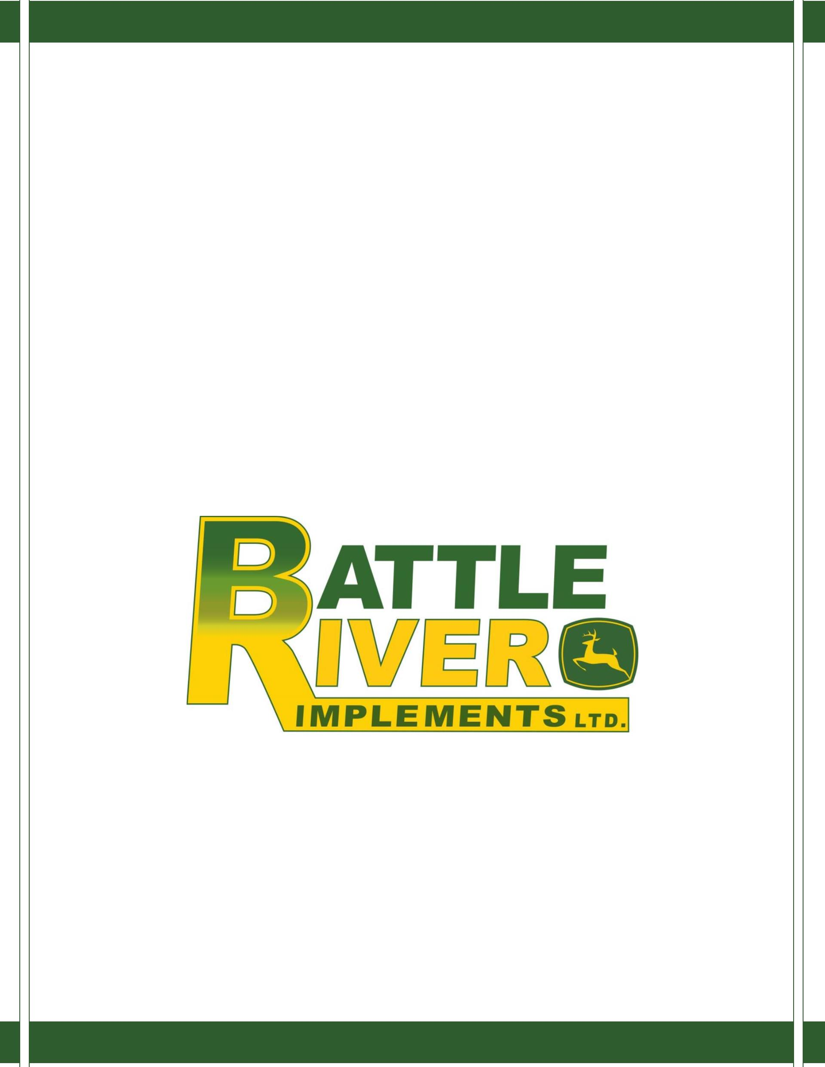

Sponsorship Request Guidelines:
Each year, we receive a high volume of requests for donations from all over Central Alberta. In an
effort to keep up with these requests, we have decided to implement an application process,
providing fair distribution across Battle River Implements Ltd. operating communities. All applications
will be reviewed in a timely manner and funding decisions will be based on our sponsorship
guidelines.
*If you approach an employee of Battle River Implements Ltd. directly for donations, you will be
referred to the online application process.*
Our donations program places priority on:
-Events/Organizations in our primary trade area.
-Youth Clubs.
-Youth Amateur Sports Teams.
Please note that the following are NOT eligible for donations:
-Political Parties.
-Religious Groups.
-Corporate/Employee Events.
-Individuals Initiatives.
-International travel, accommodations, or meal expenses; including for educational purposes.
-Individual participation in health charity fundraising drives.
We appreciate the effort of those that raise funds for the health charities through their participation in walk, run,
or ride events, but it is Battle River Implements Ltd.’s policy to contribute directly to major health charities
rather than sponsoring individual participants.
Please note that a completed application is not an agreement to honor your request. Donations to
non-profit organizations will not be given more than one time within a calendar year. A previous
donation does not guarantee a donation will be offered again for a specific event or donation amount.
By accepting a donation from our company, you are giving us permission to publish your organization
as the recipient of a donation.
Please only submit your application once. Applications are reviewed on an as received basis.
Applicants should expect a response within 3-5 weeks. Given the high volume of requests we
receive, we are unable to accommodate requests for funding on short notice. Please apply as early
as possible.

Sponsorship/Donation Request Form
Thank-you for this opportunity to support your organization, please understand we are unable
to donate to every organization/event that takes place in our operating communities. As these
opportunities are evaluated, the following are taken into consideration: is our brand values
being positively projected, does this event/program support our corporate objectives, and how
are our products and services being showcased?
Organization Name:
__________________________________________
__________________________________________
__________________________________________
__________________________________________
__________________________________________
__________________________________________
__________________________________________
Registered Charity Number:
Contact Name:
Contact Number & E-mail:
Mailing Address:
Name of Event/Program:
Event/Program Date & Duration:
Location of Event/Program (City/Province): __________________________________________
Date Response is required: __________________________________________
How many sponsors will this event have?: __________________________________________
Are any Battle River Implements Ltd. Employees involved in your organization/event?
If yes, please identify them in the space below.
Request type: (Specify donation, sponsorship, gift in kind, etc.)
If financial support is being requested, what is the total goal for the organization?
And how will the funds be used?

If gift in kind is being requested, specify what your organization requires.
How will they be used?
Has Battle River Implements Ltd. supported this event in the past (either gift in kind or
monetary) If yes, please provide details.
Which category best describes your event/organization (community, sports, education, etc.)
and why?
Why would Battle River Implements Ltd. be proud to be associated with your
event/sponsorship?
How will Battle River Implements Ltd. be recognized for its involvement with your
event/organization?
Thank-you for submitting your request; incomplete request forms will not be considered.
**Sponsorship Request Form must be submitted 6 weeks prior to the event to any
Battle River Implements location or e-mailed to terri.blackwell@briltd.com**
Office Use Only:
Received by:
Date Received:
Date Approved:
⃝Approved
⃝Declined
Approved Support:
⃝ Cash (Value)________ ⃝ Product (Value)_______ ⃝ Gift Certificate (Value)_______
⃝ Other (Value)_______

